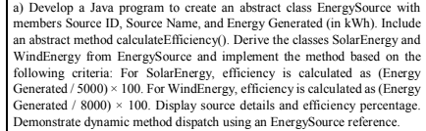

abstract class EnergySource {
String sourceId;
String sourceName;
double energyGenerated;
EnergySource(String sourceId, String sourceName, double energyGenerated) {
this.sourceId = sourceId;
this.sourceName = sourceName;
this.energyGenerated = energyGenerated;
}
abstract double calculateEfficiency();
void displayDetails() {
System.out.println("Source ID: " + sourceId);
System.out.println("Source Name: " + sourceName);
System.out.println("Energy Generated: " + energyGenerated + " kWh");
System.out.printf("Efficiency: %.2f\n", calculateEfficiency());
System.out.println("-----------------------------------");
System.out.println("Name: Bhuvanesh R");
System.out.println("USN : 1BM26CS573-T");
}
}
class SolarEnergy extends EnergySource {
SolarEnergy(String sourceId, String sourceName, double energyGenerated) {
super(sourceId, sourceName, energyGenerated);
}
double calculateEfficiency() {
return (energyGenerated / 5000.0) * 100.0;
}
}
class WindEnergy extends EnergySource {
WindEnergy(String sourceId, String sourceName, double energyGenerated) {
super(sourceId, sourceName, energyGenerated);
}
double calculateEfficiency() {
return (energyGenerated / 8000.0) * 100.0;
}
}
public class EnergyManagementSystem {
public static void main(String[] args) {
EnergySource ref;
ref = new SolarEnergy("SOL-101", "Sahara Solar Park", 3750.0);
ref.displayDetails();
ref = new WindEnergy("WND-202", "Alta Wind Energy Center", 5600.0);
ref.displayDetails();
}
}

OUTPUT :-

